Exercise 2:

Plotting the solutions:
For alpha1=alpha2=alpha3=2.6:
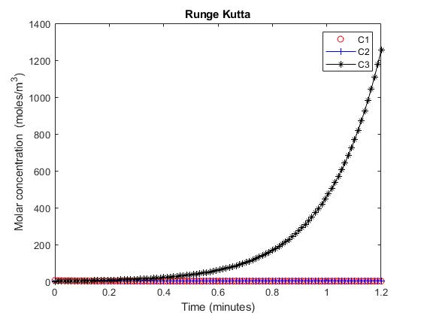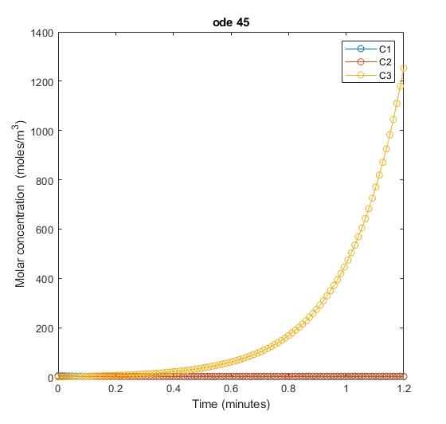

Superimposed result:
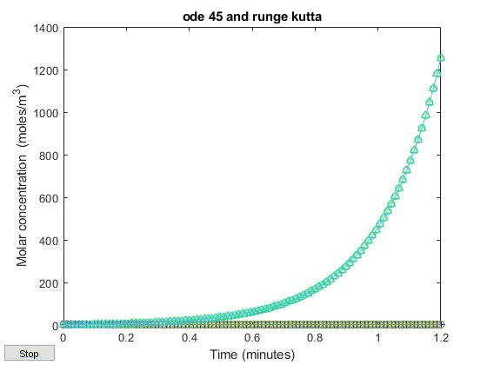

Both methods, runge kutta and ode 45, give the same result.

Plotting for values of alpha1=100000, alpha2=1, alpha3=10:
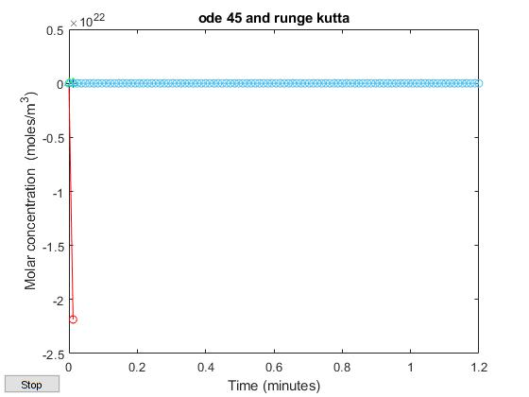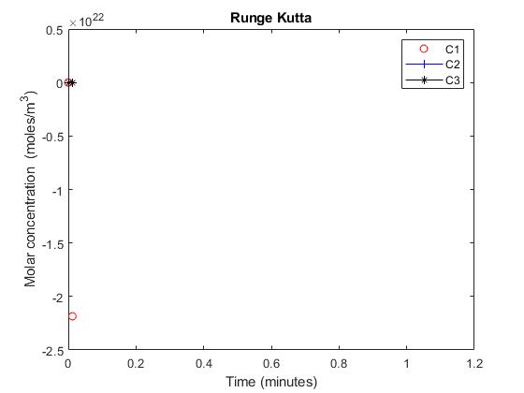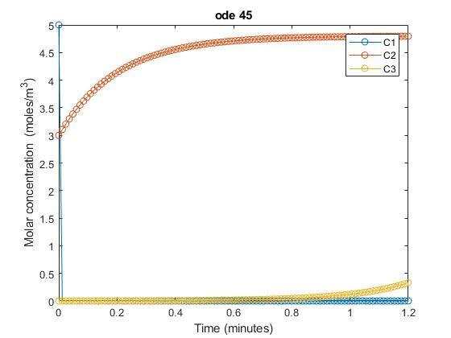
For a Runge Kutta with n=100 we still won’t be able to solve this ode system. This is because we have a stiff system.

